# Exercises: CSS Presentation and Positioning

Problems for exercises and homework for the “HTML and CSS” course @ SoftUni. Submit your solutions in the SoftUni judge system at <https://judge.softuni.bg/Contests/407/CSS-Presentation-and-Positioning>.

## Book Review

Create a Web page (HTML5 + CSS3 + images) that looks and behaves like the screenshots below:

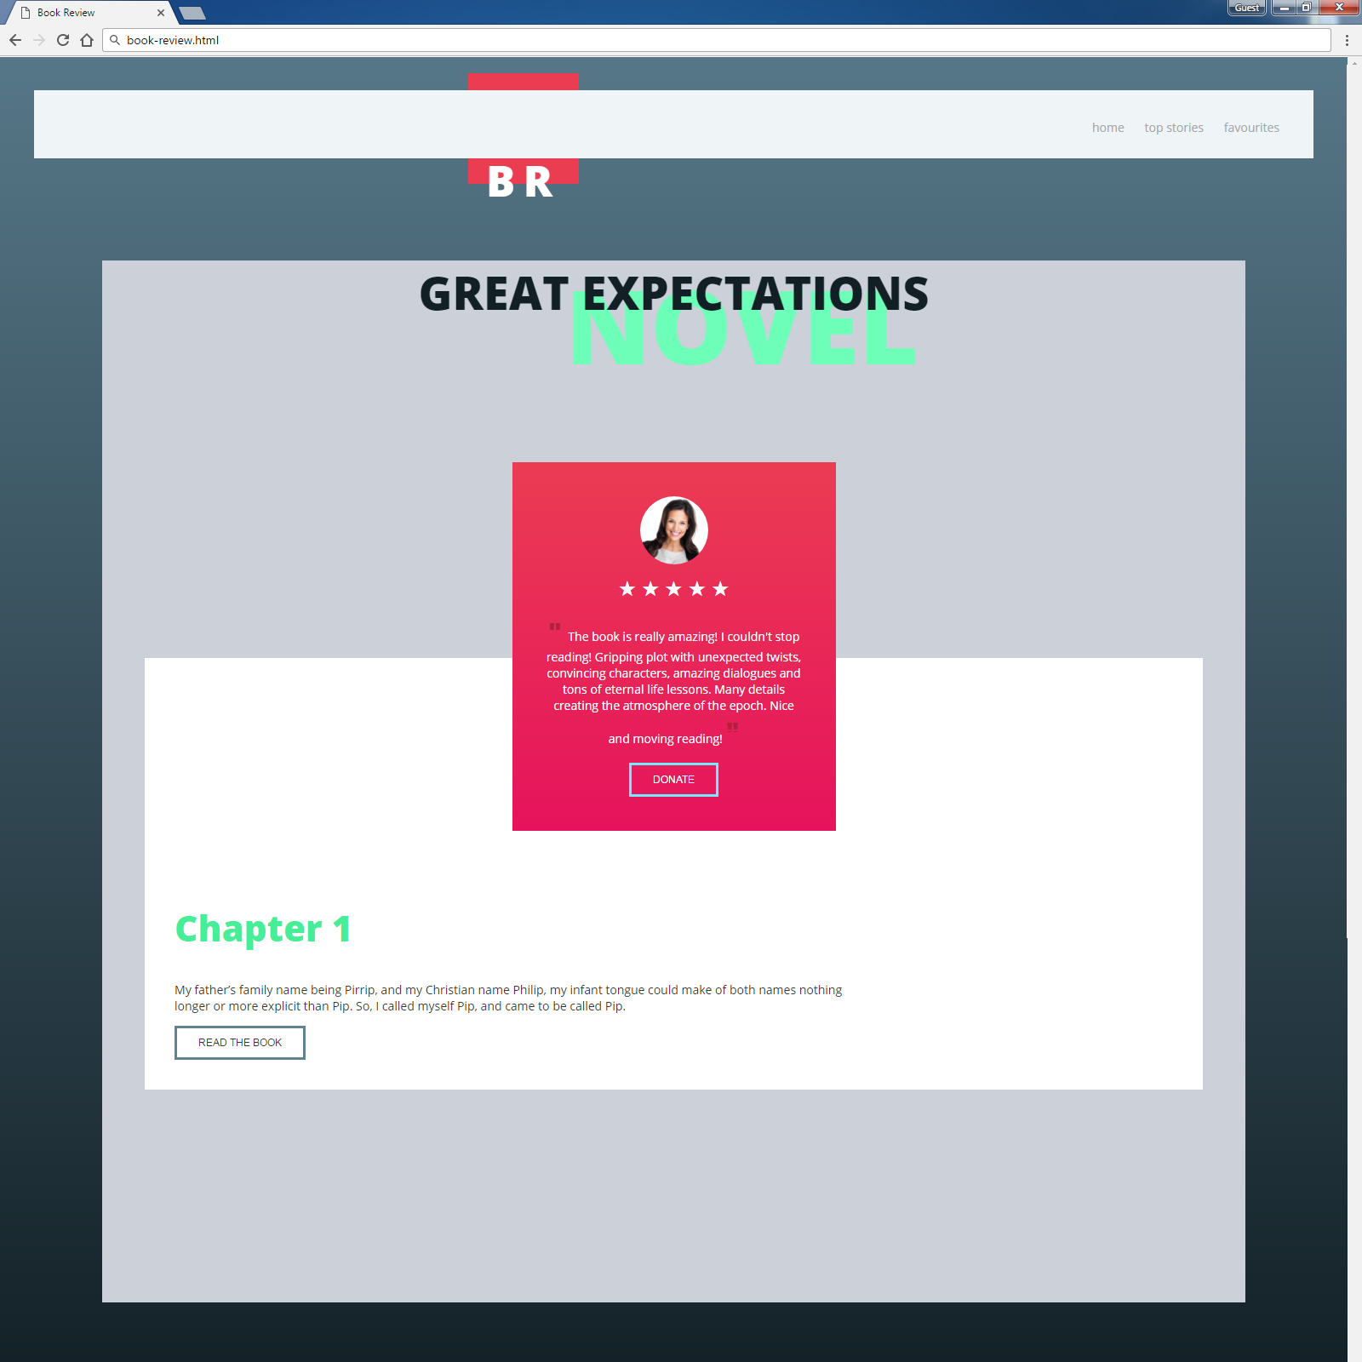

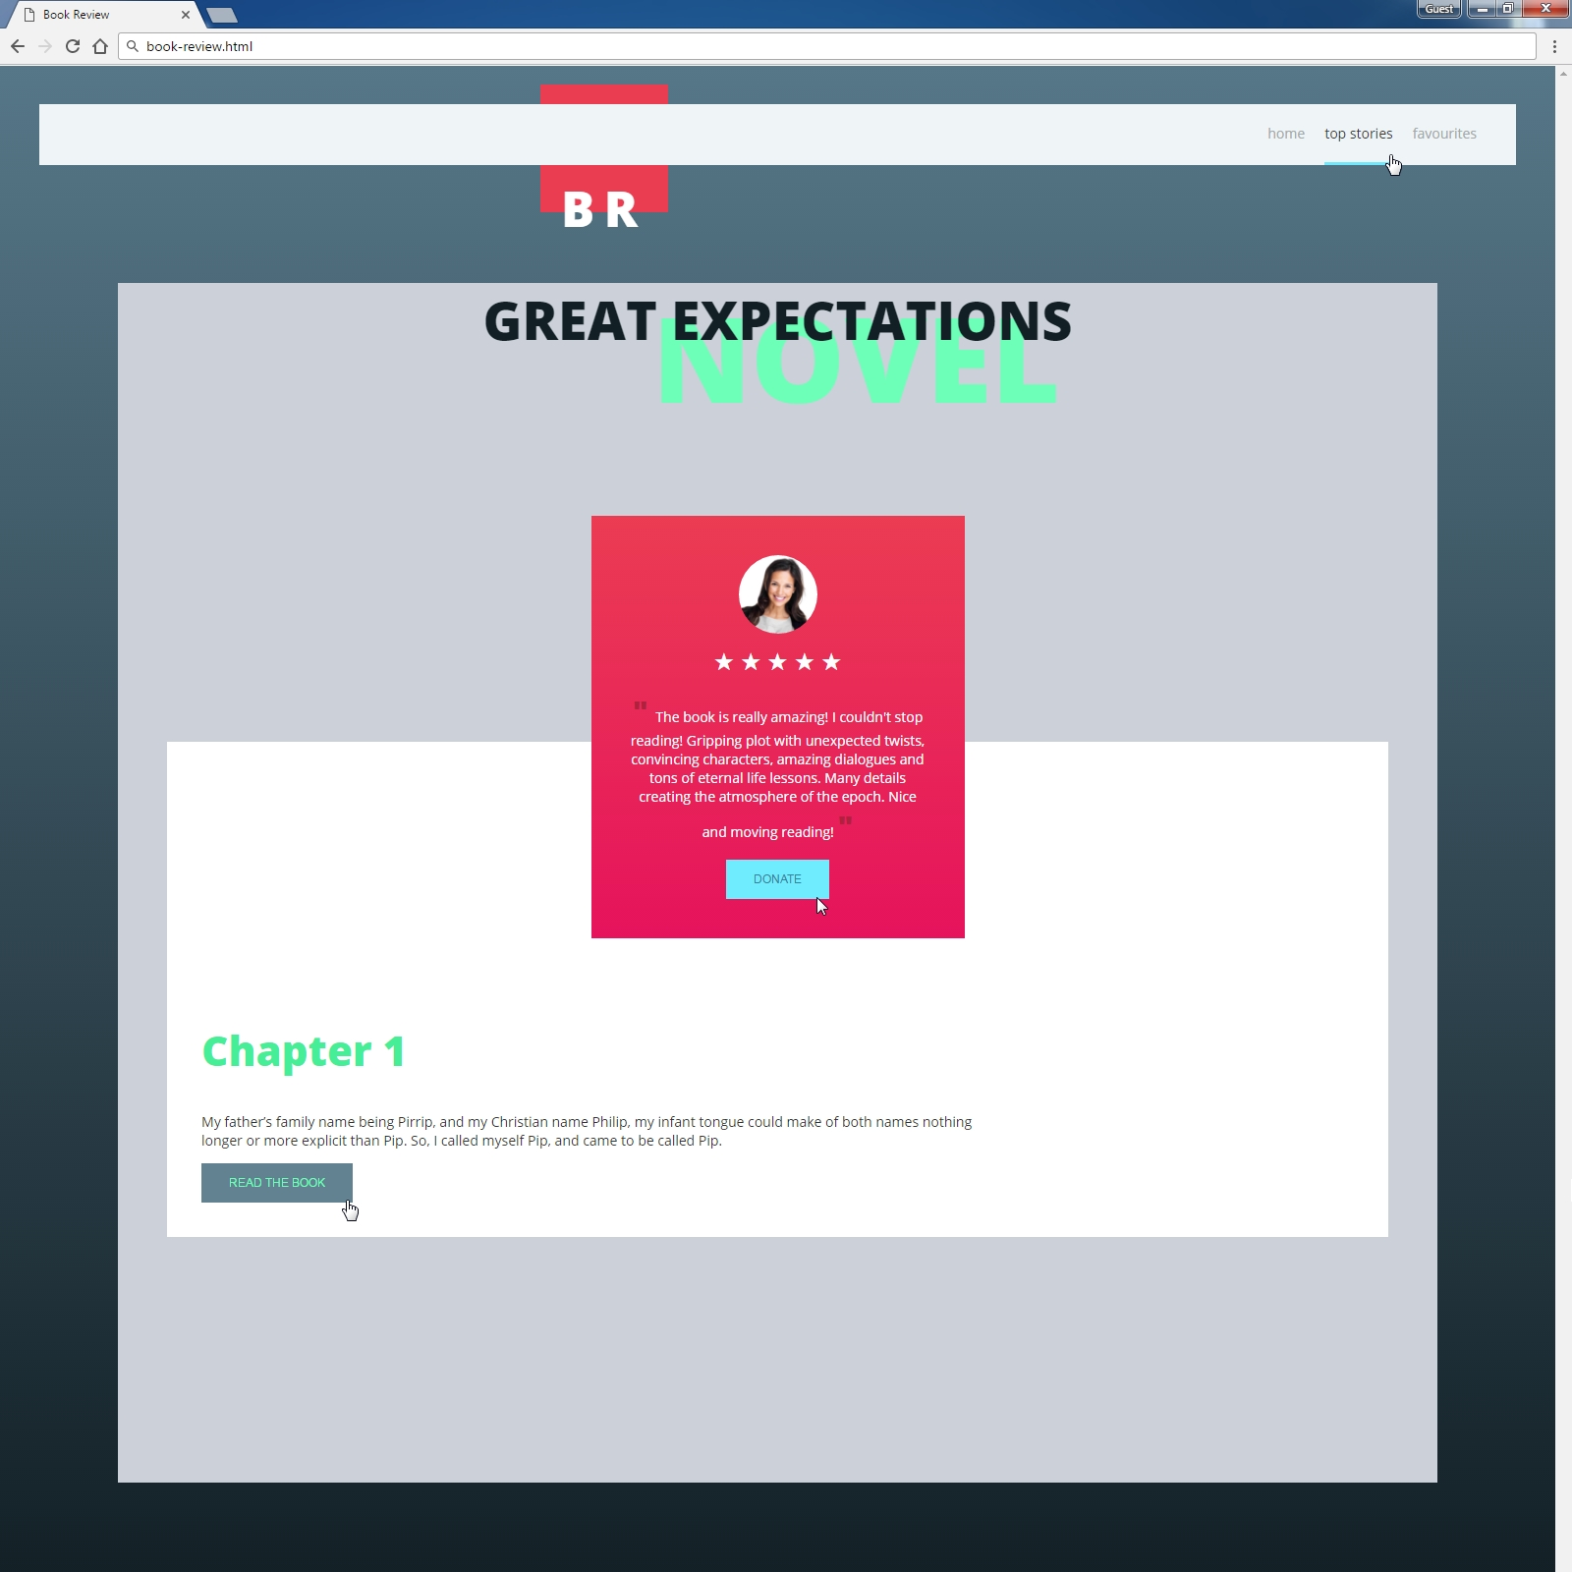

### Steps to Follow

Start with the **site header**:

* @import for the ‘**Open Sans**’ **font** from Google Fonts: <https://fonts.googleapis.com/css?family=Open+Sans:300,400,800>
* <body>
  + Margin 0px
  + Padding 0px
  + Background: linear-gradient(to bottom, #567788 0%,#121f25 100%) no-repeat center center;
  + Text font: ' Open Sans', sans-serif (font-family: 'Open Sans', sans-serif;)
  + Text size: 14px; (font-size: 14px;)
  + Text color #333333 (color: #333333;)
* Site navigation
  + Background: #eff4f7;
  + Margin: 40px;
  + Position: Relative
  + Z-Index: 5;
  + Height: 80px
* Style the hyperlinks: <a> in the site navigation
  + Remove the decoration (text-decoration: none;)
  + Text Color: #a4a8a9;
* Style the unordered list <ul> in the site navigation
  + Padding: 20px 20px 0 20px;
  + Float: Right;
* Style the list items <li> in the site navigation
  + Display: Inline Block
  + Remove the bullets
  + Margin Right: 20px;
  + Padding at the bottom: 23px
* Style the list items on hover and hyperlinks
  + Cursor: Pointer
  + Border Bottom Color: #70e9ff
  + Text Color: #333

Test the site navigation in the browser:

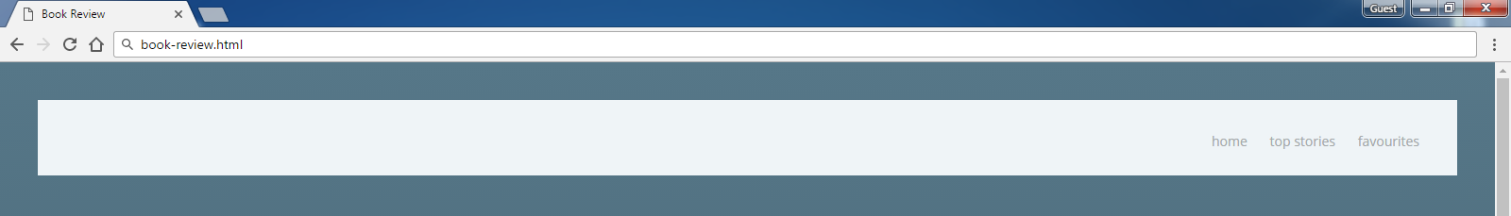

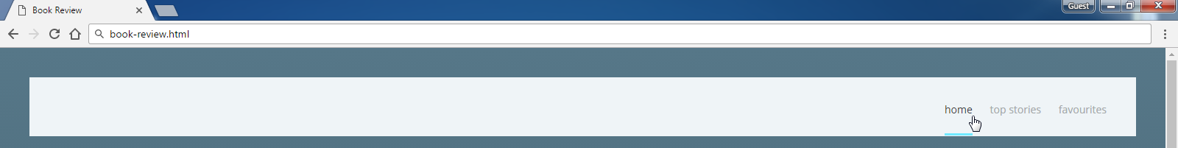

Now style the Logo at the navigation using <section> with class logo and <h1> with class brand

* Style <section> with class logo
  + Position: Absolute
  + Z Index: 0;
  + Top: -10px
  + Left: 550px
  + Background: #ea3d51;
  + Width: 140px
  + Height: 140px
  + Margin: 20px;
* Style <h1> with class brand
  + Make it UPPERCASE
  + Center the text
  + Text Size: 50px
  + Font-weight: 900
  + Space between letter: 10px
  + Text Color: #ffffff;
  + Margin at the Top: 72px;

Test the site navigation in the browser:

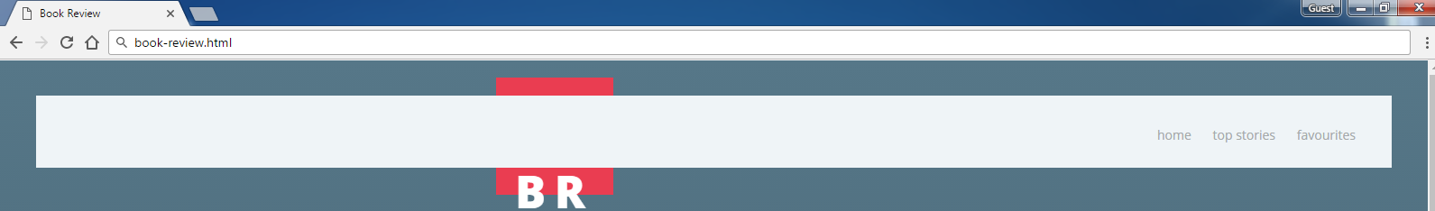

Style the Main content block:

* Make the background gray: #CBD0D9
* Use 80% width.
* Center the main section. (margin: 0 auto; padding: 0 auto;)

Now style the Header block at the main using <header> with <h1> with class **"book-title"** and <h5> with class **"book-genre"**

* Style <h1> with class "book-title"
  + Position: Relative
  + Z Index: 10;
  + Text Color: #121f25;
  + Text Size: 54px;
  + Margin: 0
* Style <h5> with class "book-genre"
  + Position: Relative
  + Z Index: 3;
  + Top: -80px;
  + Left: 80px
  + Text Color: #6dffb8;
  + Text Size: 120px;
  + Margin: 0

Test the header in the browser:

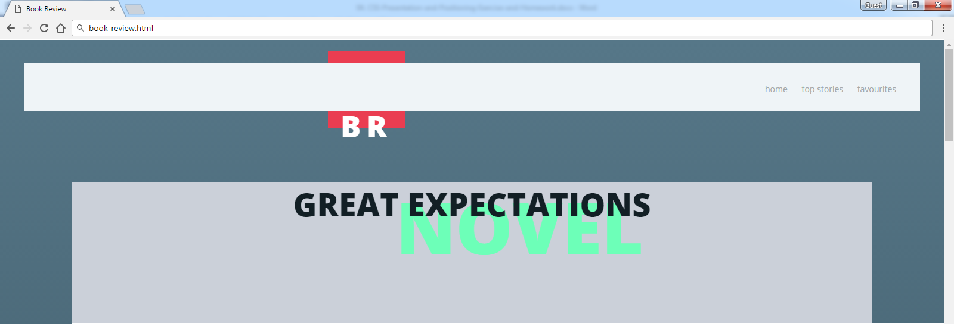

Now style the review using <section>, <img>, <button> and two paragraphs

* Style <section>
  + Position: Relative
  + Z Index: 8;
  + Center the section
  + Text Color: #ffffff;
  + Width: 300px
  + Padding: 40px
  + Center the text;
  + Background: linear-gradient(to bottom, #eb3c53 0%, #e6135c 100%) no-repeat center center;
* Style <img>
  + Display: Block
  + Center the image
  + Width: 100%
  + Max Width: 80px;
  + Border Radius: 50%
* Style the paragraph with text using before and after
  + Content: ' " ';
  + Color: #af213d;
  + Text Size: 30px
  + Font Weigth: 800;
* Style the paragraph with stars
  + Text Size: 25px
  + Margin: 10px;
  + &starf; in html
* Style the button
  + Background: None
  + Border: 3px solid #70ecff
  + Make it UPPERCASE
  + Text Size: 12px
  + Text Color: #ffffff;
  + Padding: 10px 25px;
* Style the button on hover
  + Background: #70ecff
  + Border Color: #70ecff;
  + Text Color: #348098;

Test this **section** in the browser:

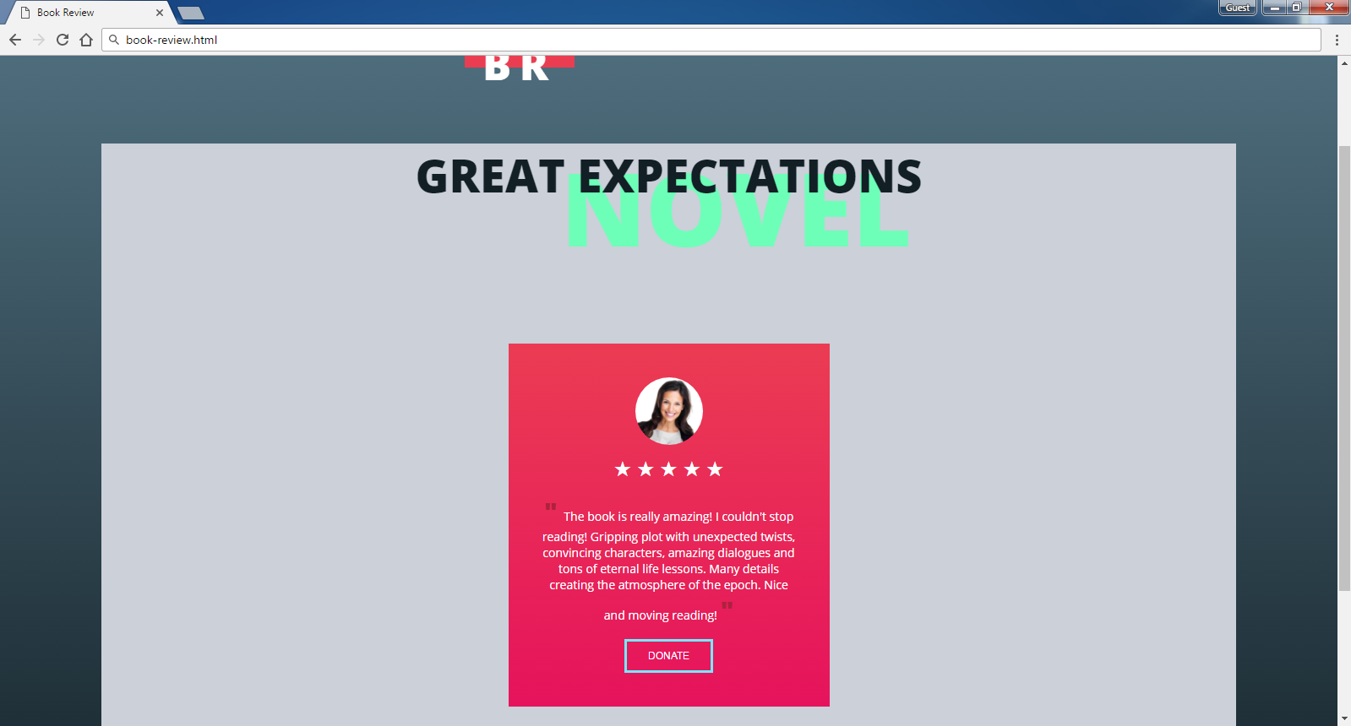

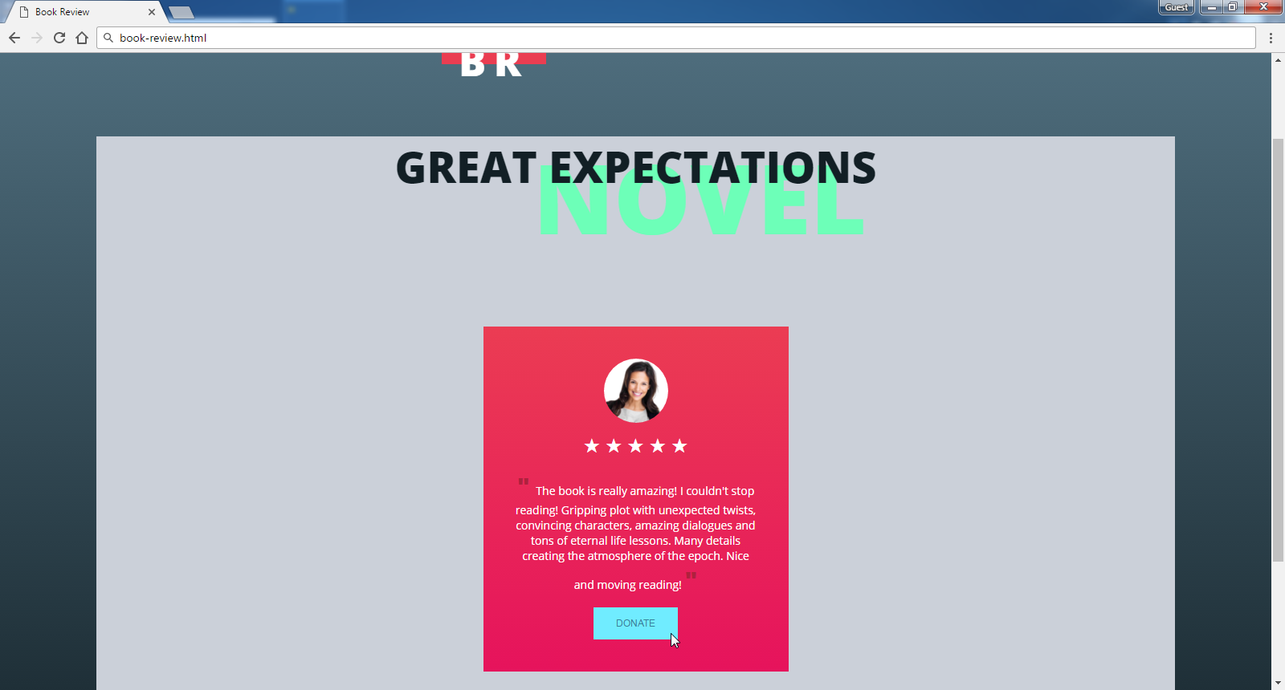

**Now** style the second <section>, <h1>, <p> and <button>

* Style <section>
  + Position: Relative
  + Z Index: 4;
  + Top: -250px;
  + Background: #ffffff;
  + Margin: 50px
  + Padding: 250px 35px 35px 35px;
* Style <h1>
  + Text Color: #46ee97
  + Text Size: 42px
* Style <p>
  + Width: 70%
* Style the button
  + Background: None
  + Border: 3px solid #628291
  + Make it UPPERCASE
  + Text Size: 12px
  + Text Color: #333;
  + Padding: 10px 25px;
* Style the button on hover
  + Background: #628291
  + Cursor: Pointer;
  + Text Color: #6dffb8;

Test the site in the Web browser again:

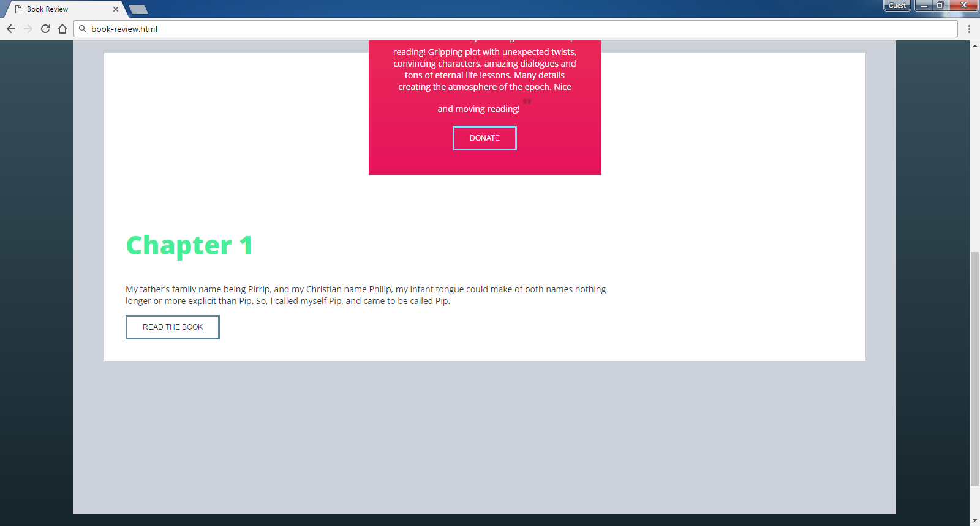

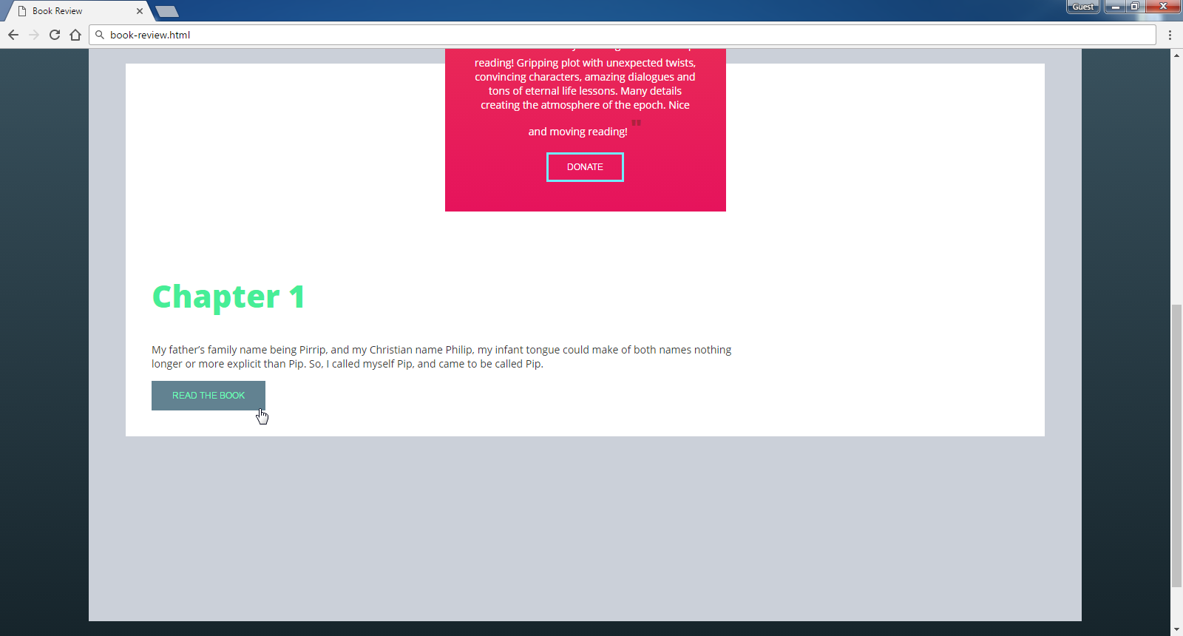

## Zora Properties

Create a Web page (HTML5 + CSS3 + images) that looks and behaves like the screenshots below:

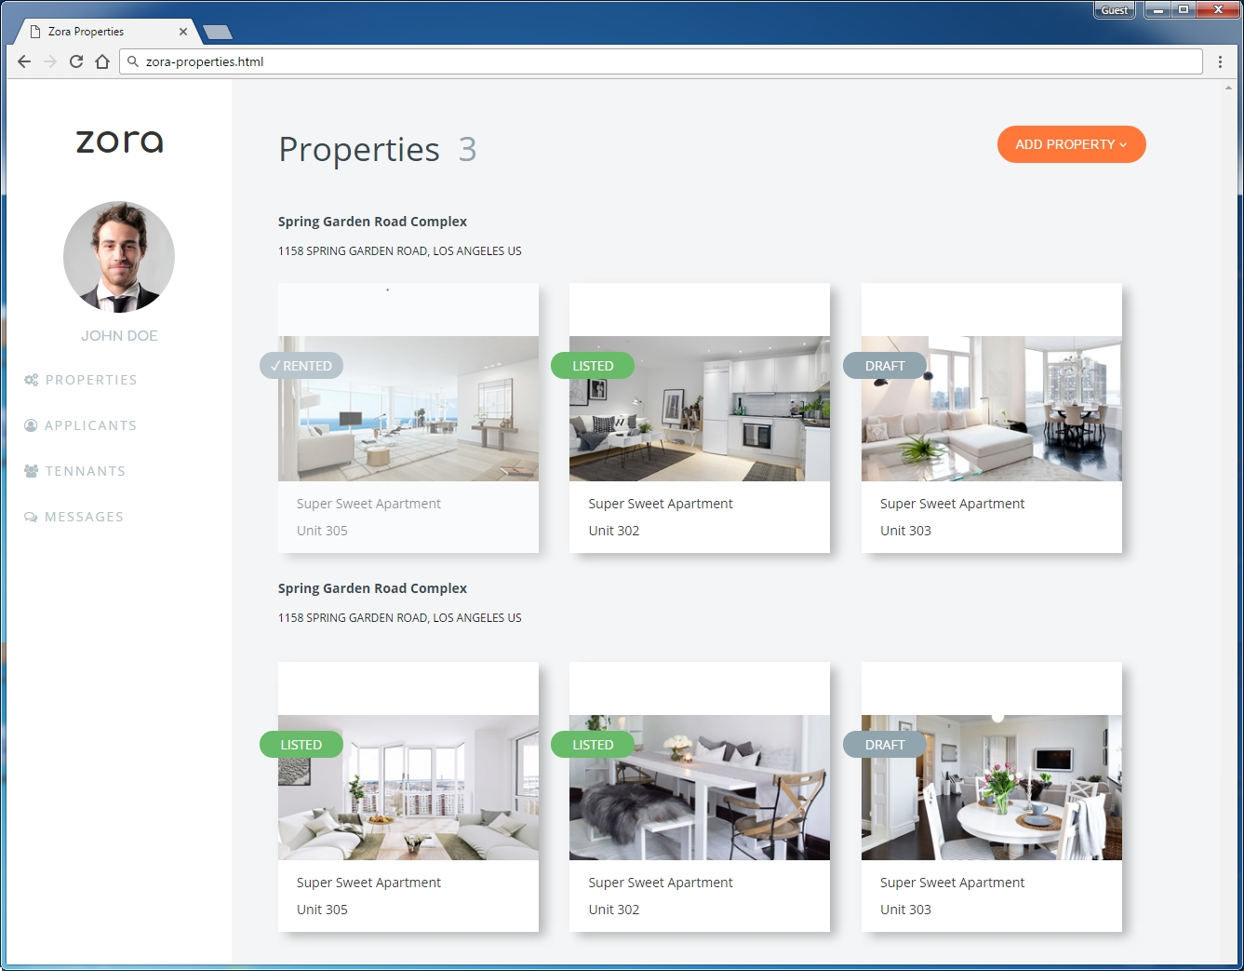

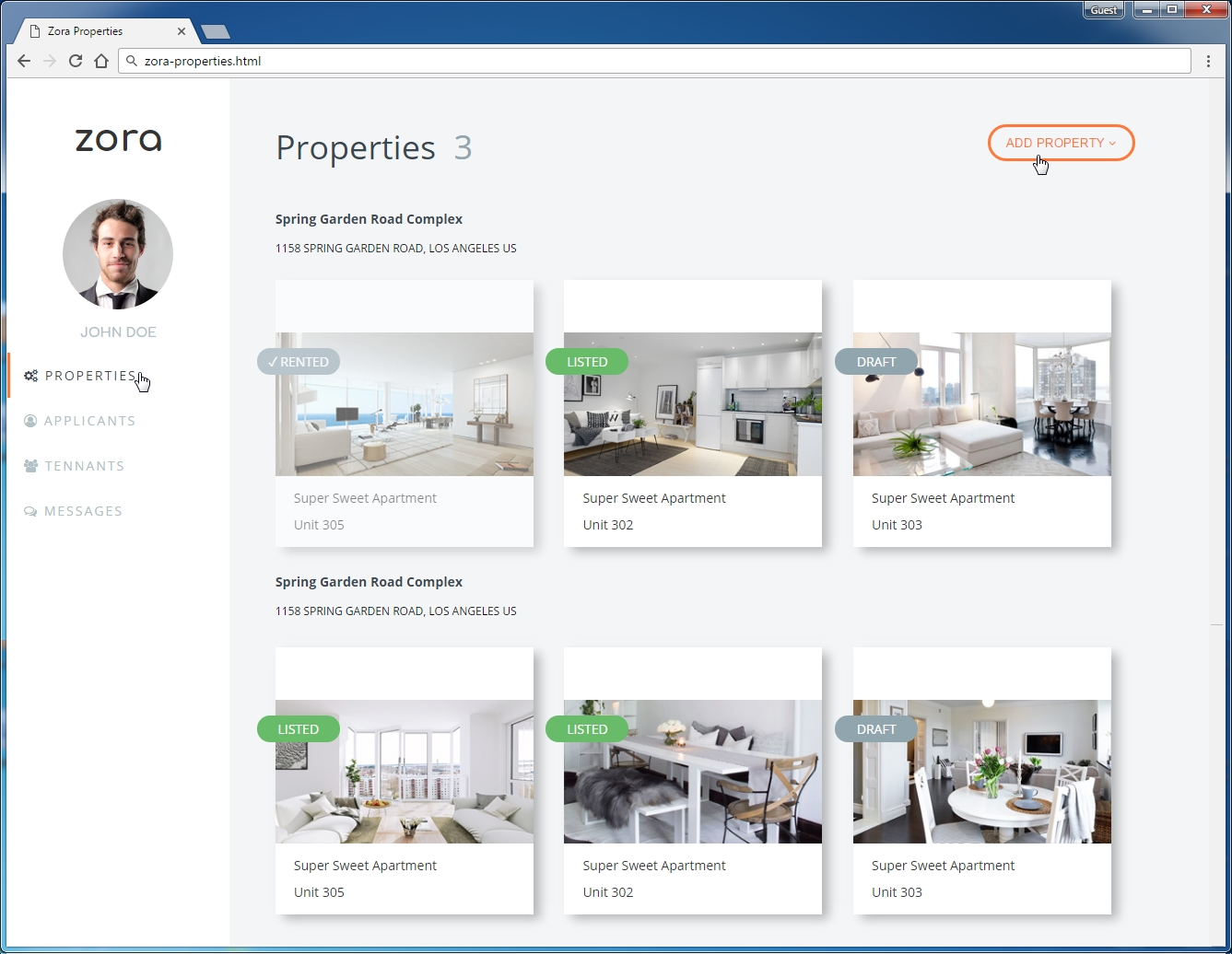

* The mouse cursors in the above screenshots explain what happens when the mouse moves over a project

### Input

You are given the above screenshots + all required images + the texts on the site.

### Output

The output should be valid HTML5 + CSS3 + images that implement the above Web page.

### Constraints

* Font: 14px "Open Sans", Arial, sans-serif; "Comfortaa", sans-serif
* Background Colors: #f3f5f7; #ff7739; #91a5af; #68bc69;
* Colors: #b1bfc6; #333; #384850; #ff7739; #91a5af;
* Pixel-perfect implementation is not required.

### Hints

For the site content structure you may use:

* Left side (sidebar): <aside> + <nav> + <ul>
  + Use left floating
* Right part (main content): <main>, <div>, <p>, <img>, <section>, <h1> to <h6>
  + Use margin-left to move the right part at its correct place

Use the following **font**, **styles** and **CSS definitions** for the left sidebar links with icons and for the orange button on the right:

 

* @import url('<https://fonts.googleapis.com/css?family=Comfortaa:700|Open+Sans:400,700>');
* @import url('<https://maxcdn.bootstrapcdn.com/font-awesome/4.7.0/css/font-awesome.min.css>');
* <i class="fa fa-cogs" aria-hidden="true"></i>
* <i class="fa fa-user-circle-o" aria-hidden="true"></i>
* <i class="fa fa-users" aria-hidden="true"></i>
* <i class="fa fa-comments-o" aria-hidden="true"></i>
* <i class="fa fa-angle-down" aria-hidden="true"></i>

For the **property listings** you may use:

* Box Shadow: 8px 6px 17px -1px rgba(0,0,0,0.26);

For the **property labels**, use relative positioning:

 

For the **checkmark** character (✓) use the following HTML entity: &check;

# * Exam Problems

**All of the problems below are given on Web Fundamentals (HTML & CSS) Practical Exams.**

**You are not obligated** to submit any of them in your homework. We highly recommend you to try solving some or all of them so you can be well prepared for the upcoming exam. If you still find those problems too hard for solving it’s very useful to **check** and **understand** the solutions.

## Option Panels

Create a Web page (HTML5 + CSS3 + images) that looks and behaves like the screenshots below:

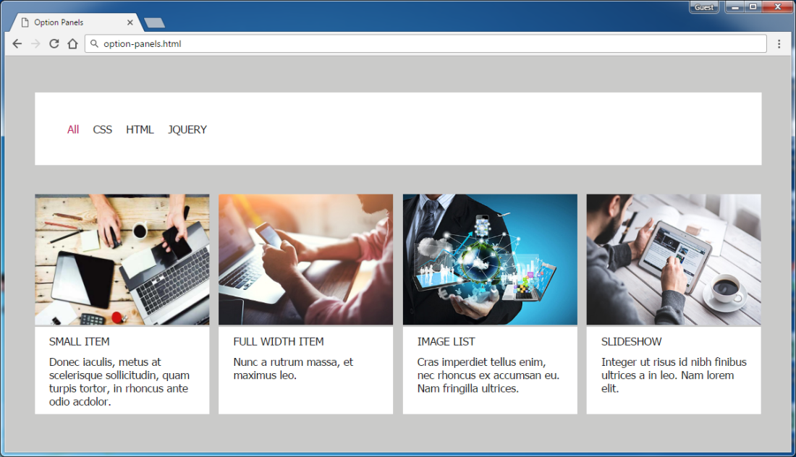

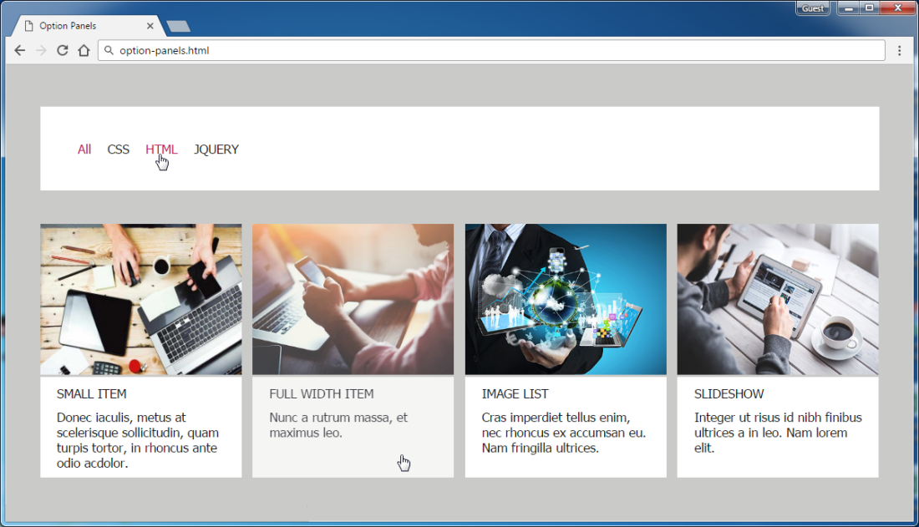

* The mouse cursors in the above screenshots explain what happens when the mouse moves over a project or a group and when the browser window resizes.

### Input

You are given the above screenshots + all required images + the texts on the site.

### Output

The output should be valid HTML5 + CSS3 + images that implement the above Web page.

### Constraints

* The layout is body-centered and should be 1000px.
* Font: 15px Tahoma, Arial, sans-serif; Default text color is #191923;
* The links at the navigation - current state and hover-effect color: #BF1363
* There are 4 sections which are fully linkable and hover effect is transparency **0.8** of all the section.
* Pixel-perfect implementation is not required.

## BBC News

Create a Web page (HTML5 + CSS3 + images) that looks and behaves like the screenshots below:

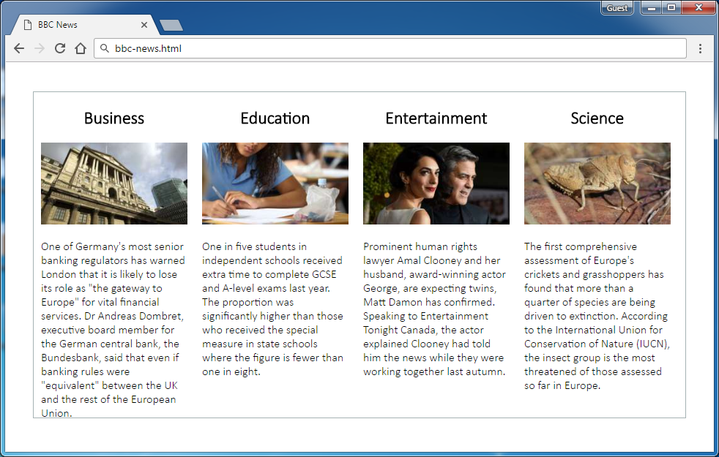

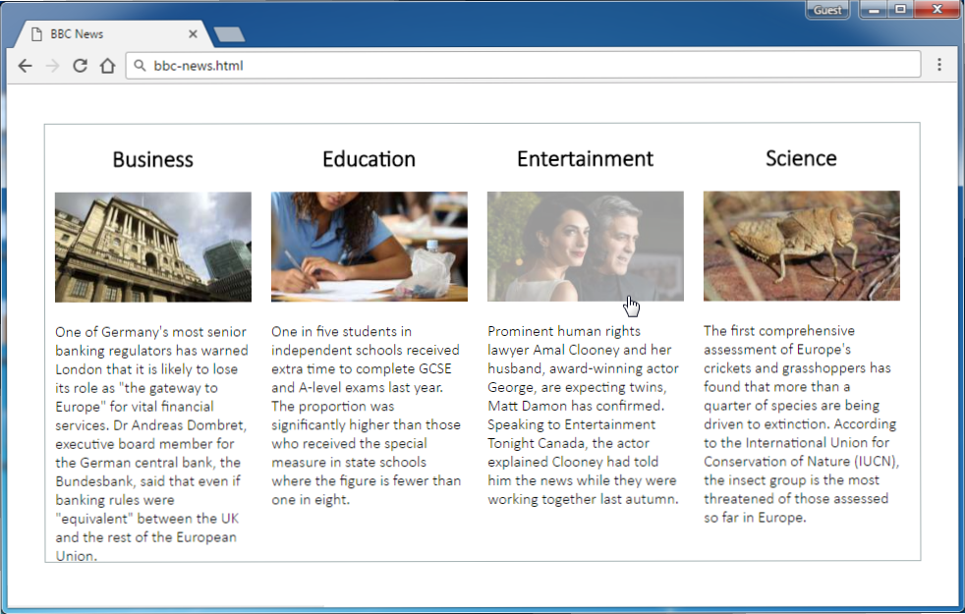

* The mouse hand-pointers and the bottom bar in the screenshots are not part of your page, so please skip them.

### Input

You are given the above screenshots + the images for the above three news items + the texts on the site.

### Output

The output should be valid HTML5 + CSS3 + images that implement the above Web page.

### Constraints

* The layout is body-centered and should be 890px.
* Font: Calibri Light / Verdana / sans-serif.
* Border color: #a5b2b3;
* There are 4 articles with image fully linkable and hover effect is transparency **0.4** of all the images.
* Pixel-perfect implementation is not required.

## IT News

Create a Web page (HTML5 + CSS3 + images) that looks and behaves like the screenshots below:

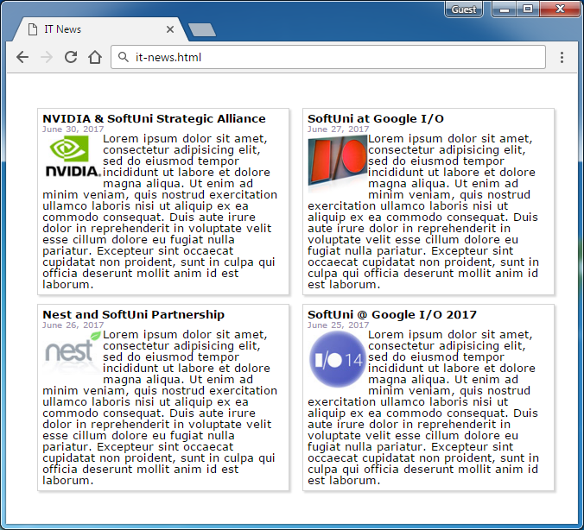

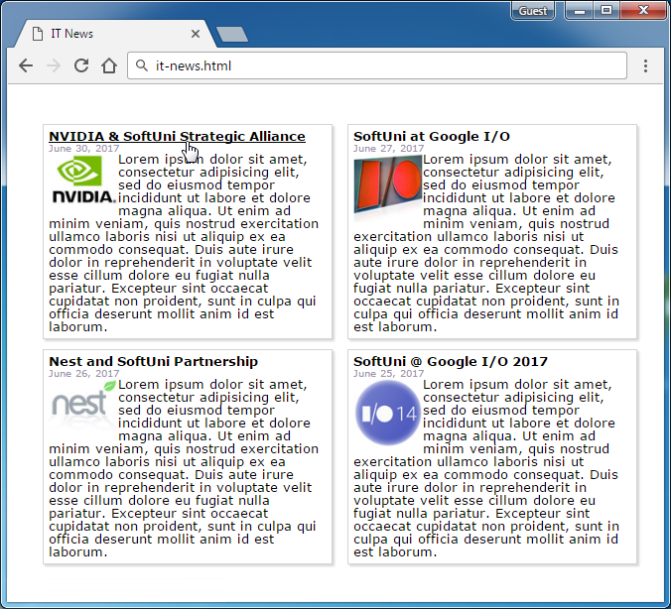

* The mouse hand-pointers and the bottom bar in the screenshots are not part of your page, so please skip them.

### Input

You are given the above screenshots + the images for the news items + the texts on the site.

### Output

The output should be valid HTML5 + CSS3 + images that implement the above Web page.

### Constraints

* The layout is body-centered and should be 610px.
* Font: Verdana / Arial / Helvetica (size: 13px for the titles / 10px for the dates / 13px for the texts).
* Text color: #A192B0**;**
* Column width: 280px.
* There are 4 articles.
* Pixel-perfect implementation is not required.

## Pricing List

Create a Web page (HTML5 + CSS3 + images) that looks and behaves like the screenshots below:

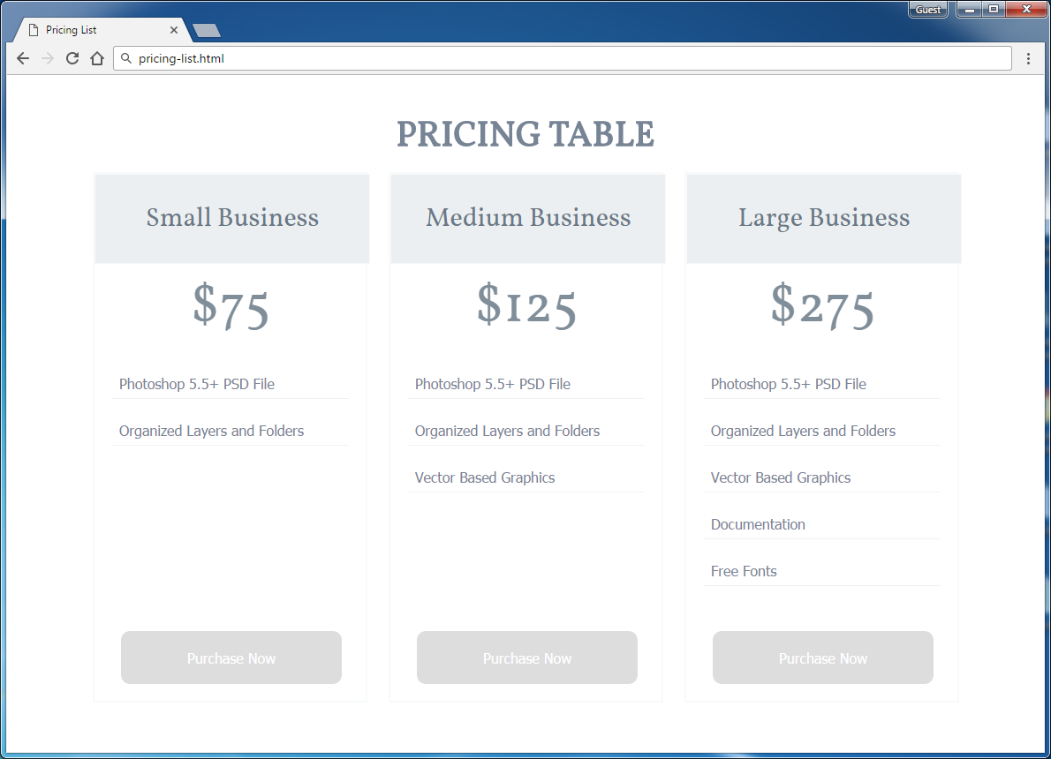

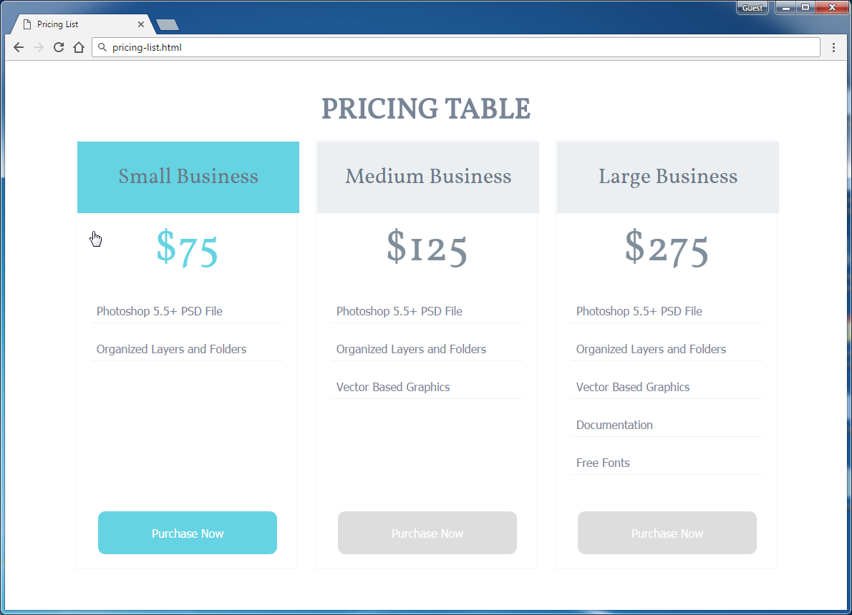

* The mouse hand-pointers and the bottom bar in the screenshots are not part of your page, so please skip them.

### Input

You are given the above screenshots + the images for the above three news items + the texts on the site.

### Output

The output should be valid HTML5 + CSS3 + images that implement the above Web page.

### Constraints

* The layout should be 1000px.
* Use google font **Vollkorn** - <https://www.google.com/fonts#UsePlace:use/Collection:Vollkorn>
* 'Vollkorn', serif; (size: 40px for the title, 30px for the subtitle, 60px for the price).
* Font: 16px Tahoma, sans-serif for the main text.
* **Button** for Purchase now
* There are 3 articles.
* Pixel-perfect implementation is not required.

## Numbers

Create a Web site (HTML5 + CSS3) that looks and behaves like the screenshots below:

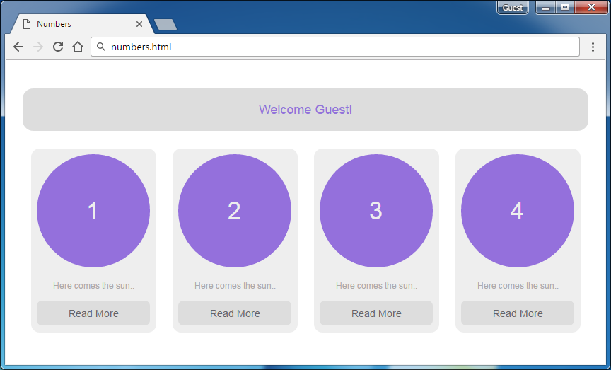

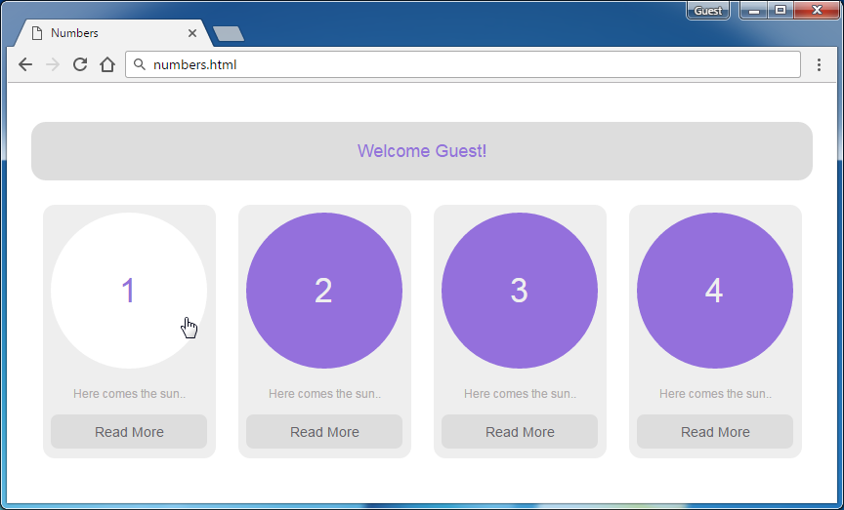

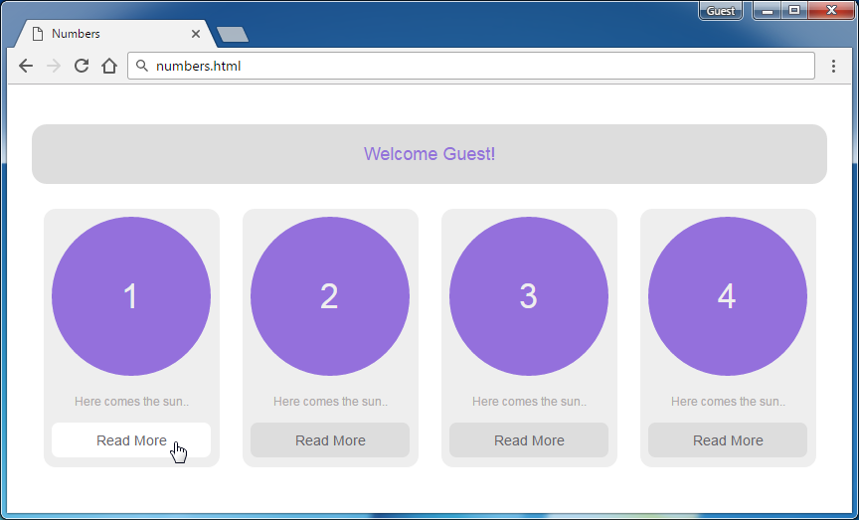

* The hand cursors in the screenshots show what happens when the mouse moves over certain elements.

### Input

You are given screenshots + the texts on the site.

### Output

The output should be valid HTML5 + CSS3 that implement the above Web site.

### Constraints

* Fonts:
  + Site content: Arial, Helvetica, sans-serif; 12px.
  + Heading 18px
  + Button Read More: 14px.
* Site content: fixed width 800px.
* There are 4 articles
* Pixel-perfect implementation is not required.
* Take the colors from the pictures with color picker.

## Services

Create a Web site (HTML5 + CSS3) that looks and behaves like the screenshots below:

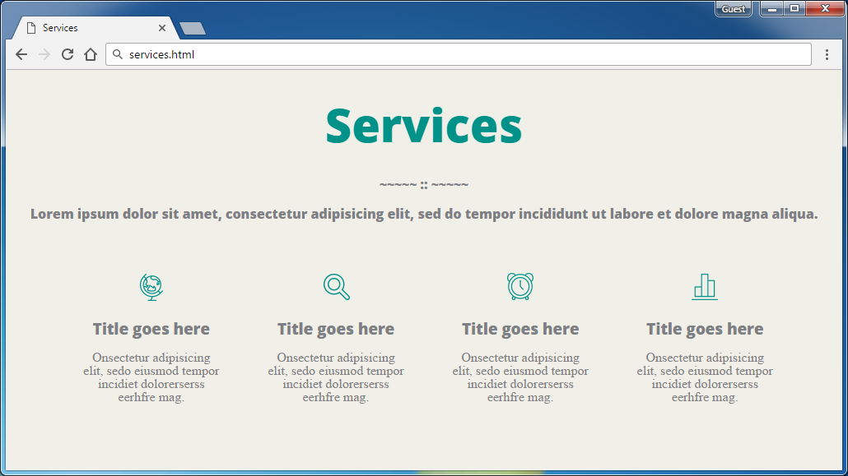

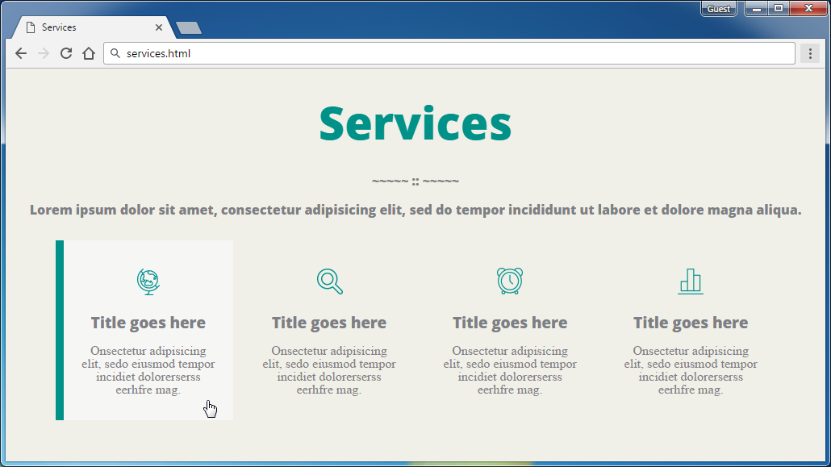

* The hand cursors in the screenshots show what happens when the mouse moves over certain elements.

### Input

You are given the above screenshots + the required font + all required images + the texts on the site.

### Output

The output should be valid HTML5 + CSS3 that implement the above Web site.

### Constraints

* The font in the entire page is OpenSans-ExtraBold / Helvetica / sans-serif (size: 56px for the main heading, 16px for the texts).
* Column width: 220px with all margins + paddings.
* There are 4 articles
* Pixel-perfect implementation is not required.

## Watch Store

Create a Web site (HTML5 + CSS3) that looks and behaves like the screenshots below:

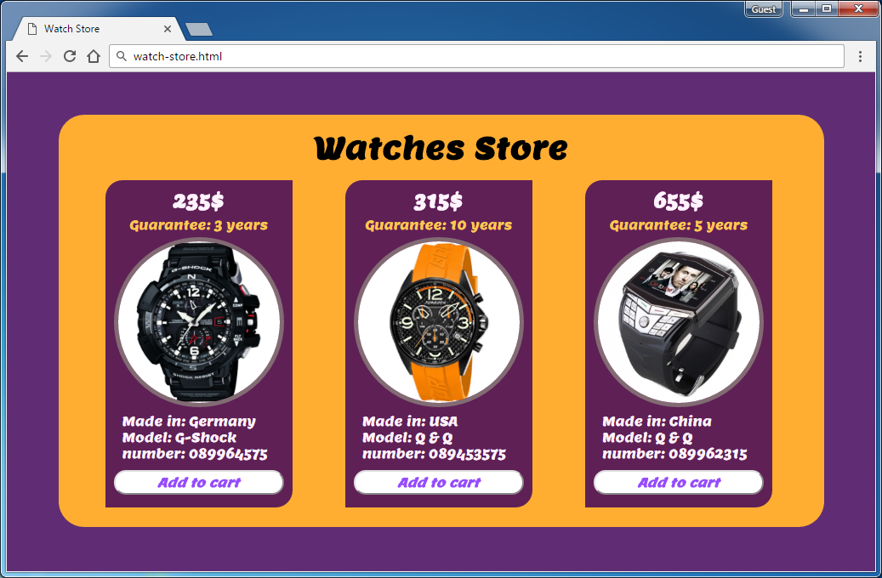

### Input

You are given the above screenshots + the required font + all required images + the texts on the site.

### Output

The output should be valid HTML5 + CSS3 that implement the above Web site.

### Constraints

* Font: Lemon-Regular / Arial
* Font size: **24px** for the main title, **22px** for price of watches, **15px** for info of the watches, **15px** for the buttons.
* Watches container width: 900px.
* Columns width: 220px.
* There are 3 articles
* Responsive design is not required.